**R Code for Examples in the book**

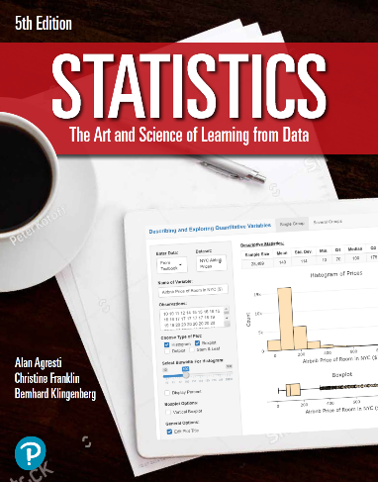

***“Statistics: The Art and Science of Learning from Data”***

**by Agresti, Franklin and Klingenberg, 5th edition**

**Chapter 6**

**Example 9: Relative Standing on the SAT – Using z-Scores to Find Percentiles**

## To compute the z-Score of an SAT score of 650 in a component

z <- (650 - 500) / 100  
z

## [1] 1.5

## To find the percentage of SAT scores higher than 650 for some component

pnorm(650, mean = 500, sd = 100, lower = FALSE)

## [1] 0.0668072

## or using the z-score

pnorm(z, lower = FALSE)

## [1] 0.0668072